TABLE OF CONTENTS
Key Layout 2
Section 1.2 #
Section 1.3 #

Key Layout
C1 – Legato Center
C#1 – Legato Mid
D1 – Legato Edge
D#1 – Shot Rim
E1 – Shot Ping
F1 – Shot Cross Stick
F#1 – Click Rim
G1 – Buzz (Loose) Center
G#1 – Buzz (Loose) Mid
A1 – Buzz (Loose) Edge
A#1 – Buzz (Pressed) Center
B1 – Buzz (Pressed) Mid
C2 – Buzz (Pressed) Edge
C#2 - Backstick
D2 – Click Shell (4 RR)
D#2 – Click Sticks (4 RR)
E2 – Doublestops
F2 – flams
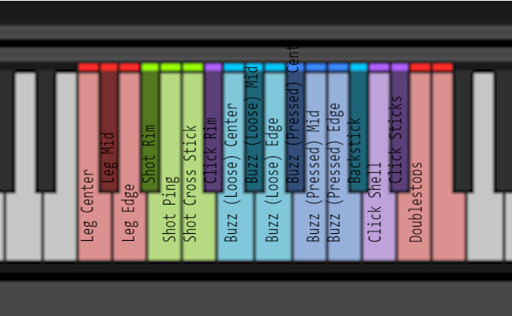

Notes on Round Robins
Each articulation has 6 Round Robins, with the exception of Shell and Stick clicks which have 4.

Mic Positions
Each articulation has been recorded with 4 mic positions which can be adjusted with the mic position faders.

AB (Buss 1) – Lom USI Pro in an AB spaced array in front of the drum. Bright, snappy, and wide.
XY (Buss 2) – Blue Bluebird XY array in front of the drum. Mono compatible, dark, and articulated.
Top (Buss 3) – SM57 on the batter head. Detailed with lots of attack. Punchy.
Bottom (Buss 4) – SM57 on the resonant head, near the snares. Bright and resonant. Detail of the snares.

